COMPUTER NETWORK

LAB EXPRIMENTS

Courses code: CSA 0763

Name: Sadam sneha

Reg no.192211350

Experiment 01 ARP

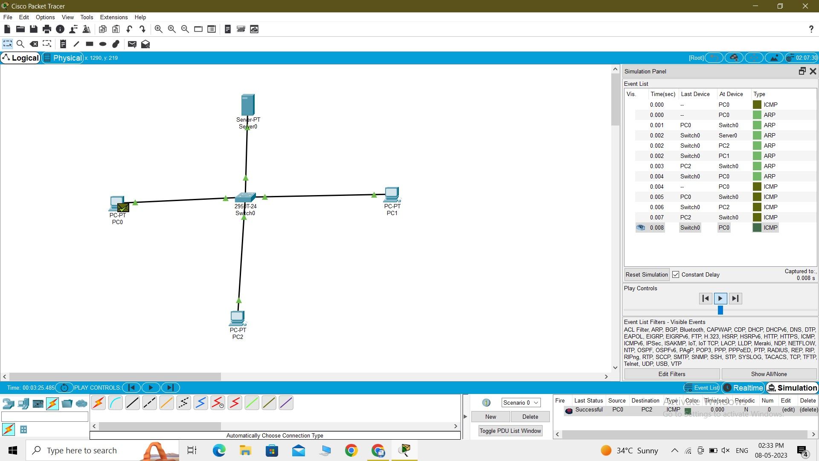

Experiment 02

star,mesh,tree topologies

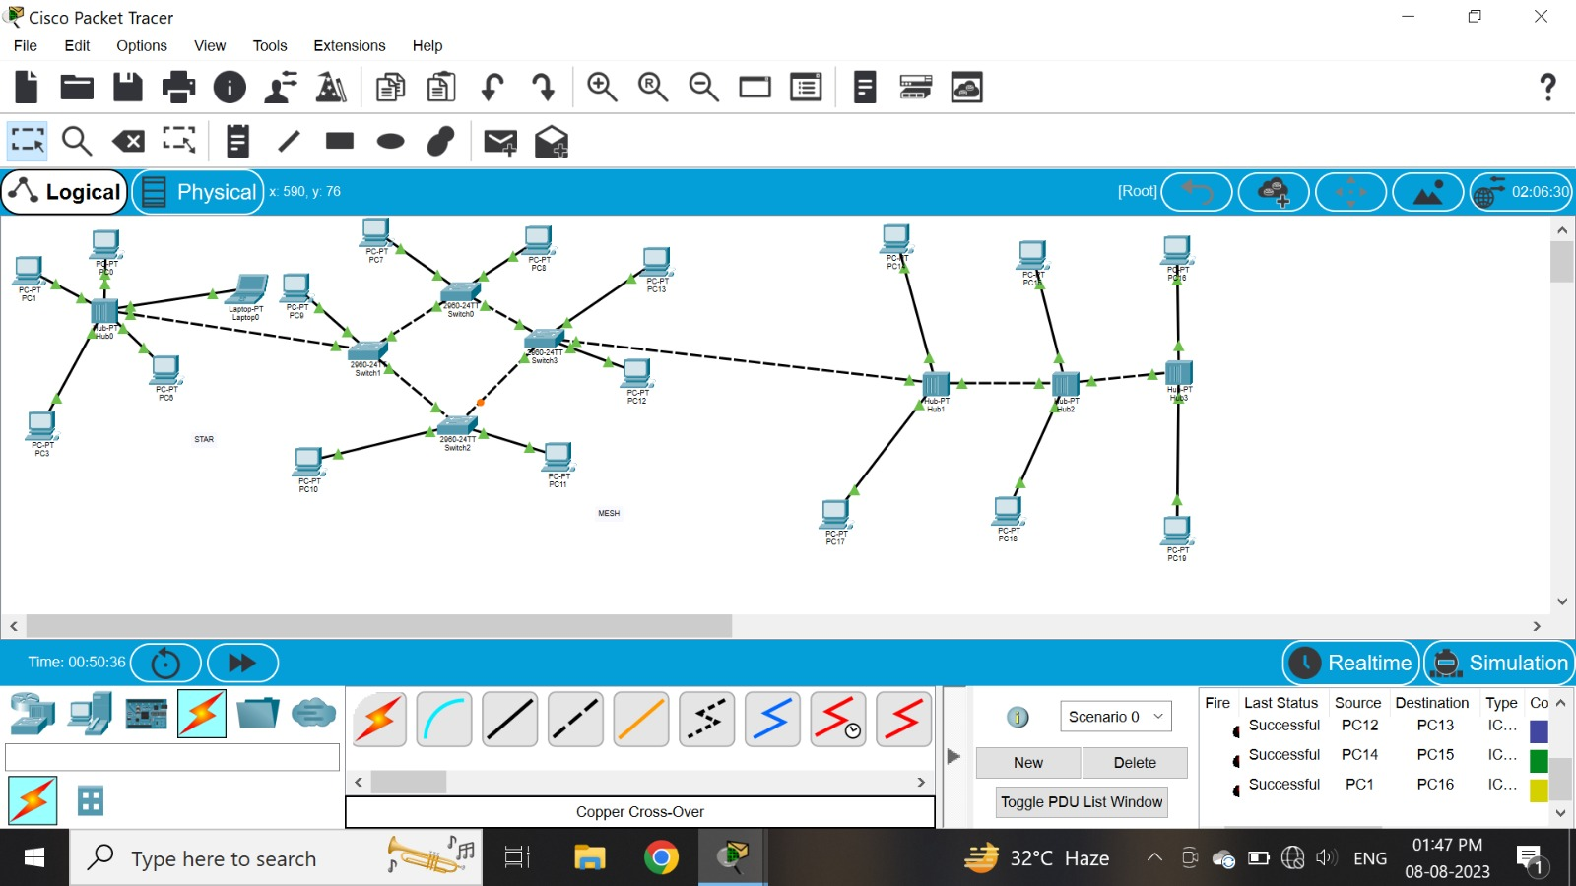

Experiment 03

bus,ring,hybrid

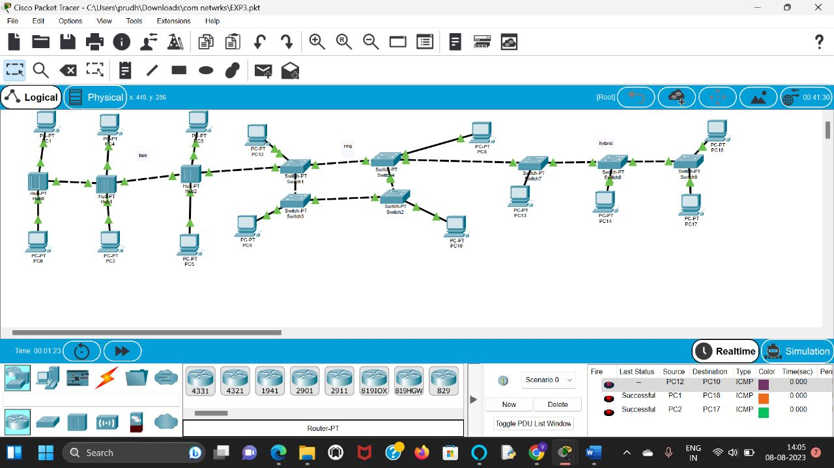

Experiment 04

link layer traffic of csma/cd& csma/ca

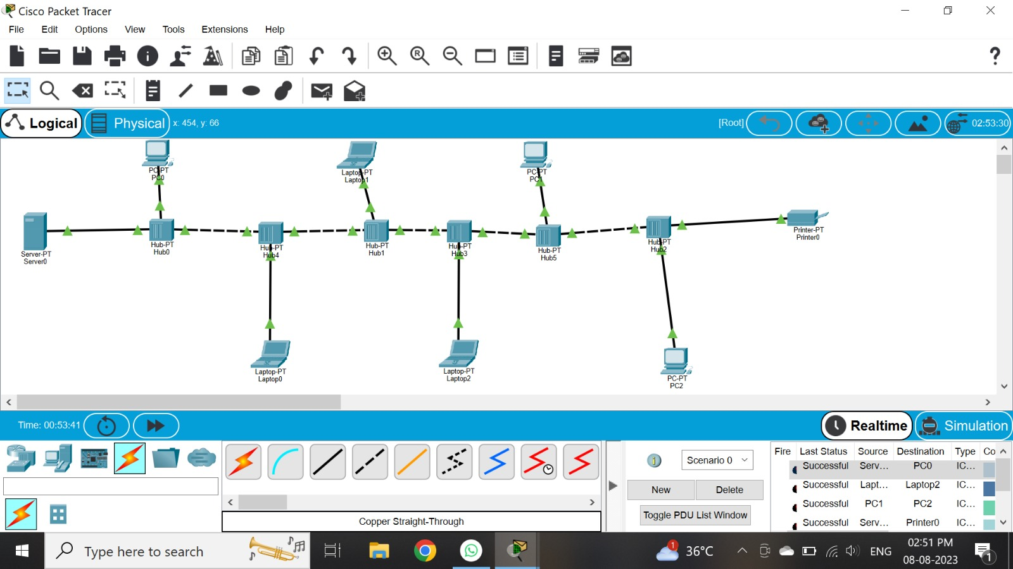

Experiment 05

Data link layer traffic using packet tracer analysis of ARP

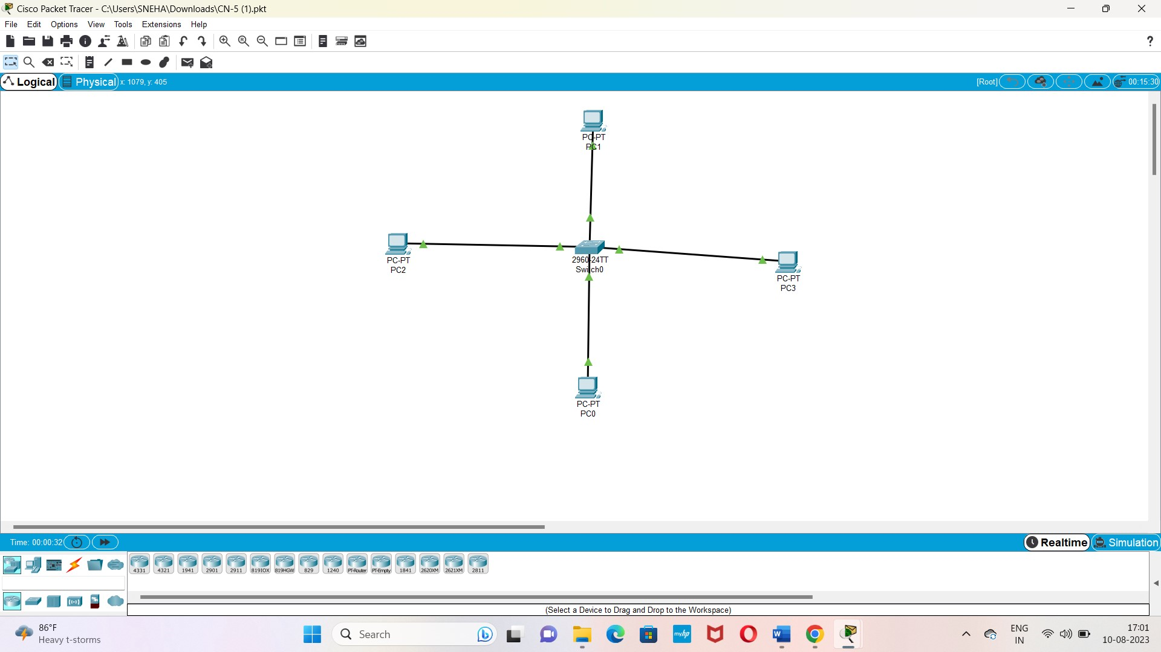

Experiment 06

Static routing using packet tracer

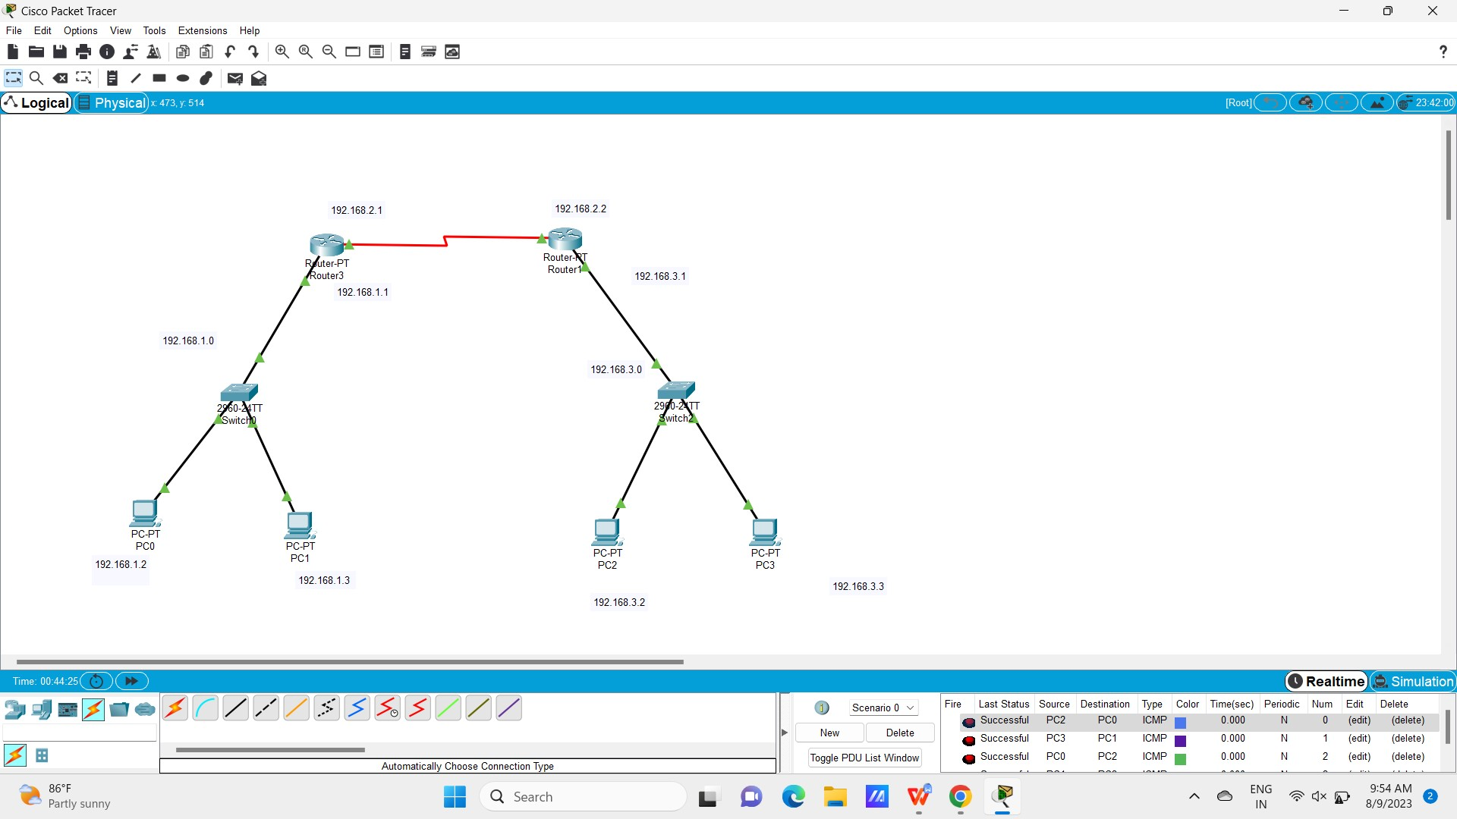

Experiment 07

Dynamic routing using tracer (ospf)

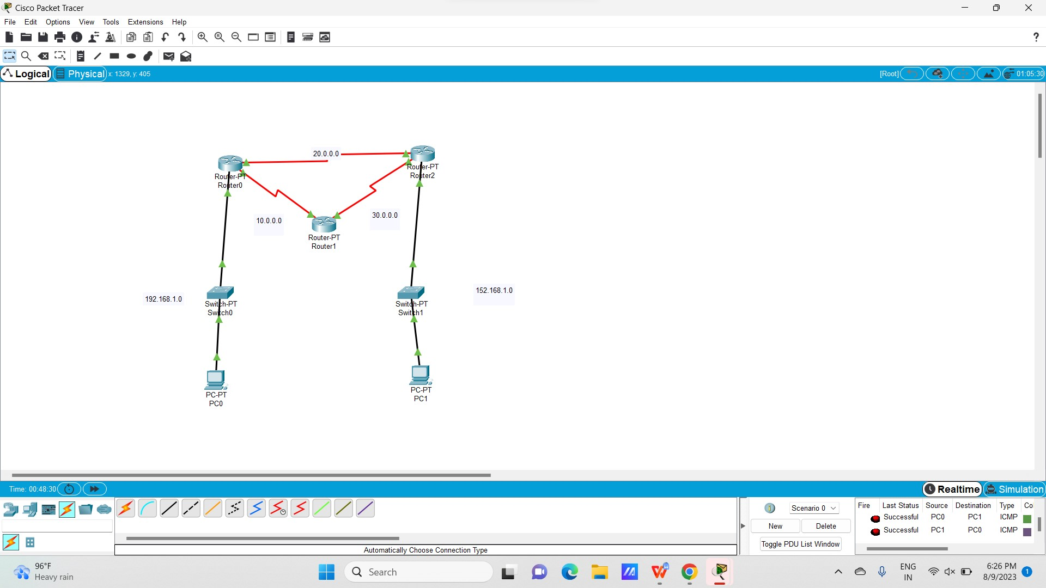

Experiment 08

subnetting class c addressing

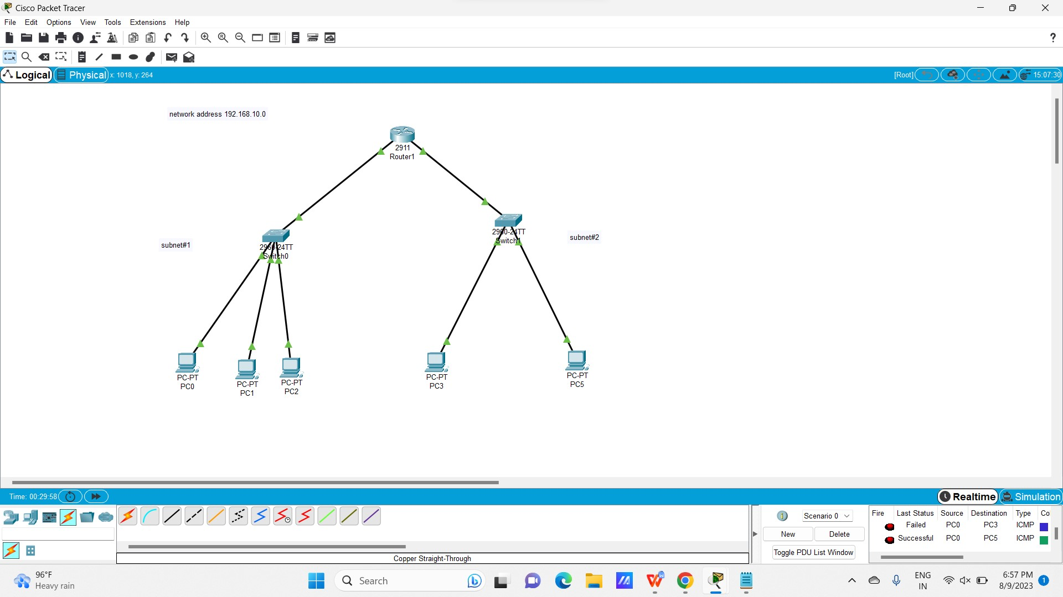

Experiment 09 functionalities of TCP,UDP

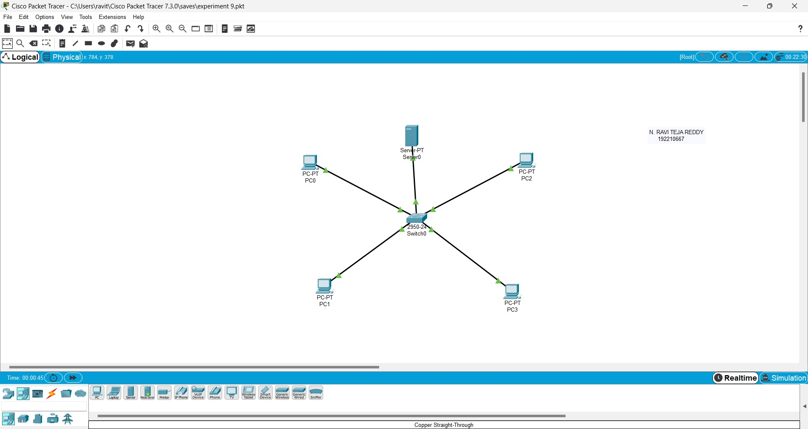

Experiment 10 TCP,UDP exploration solution

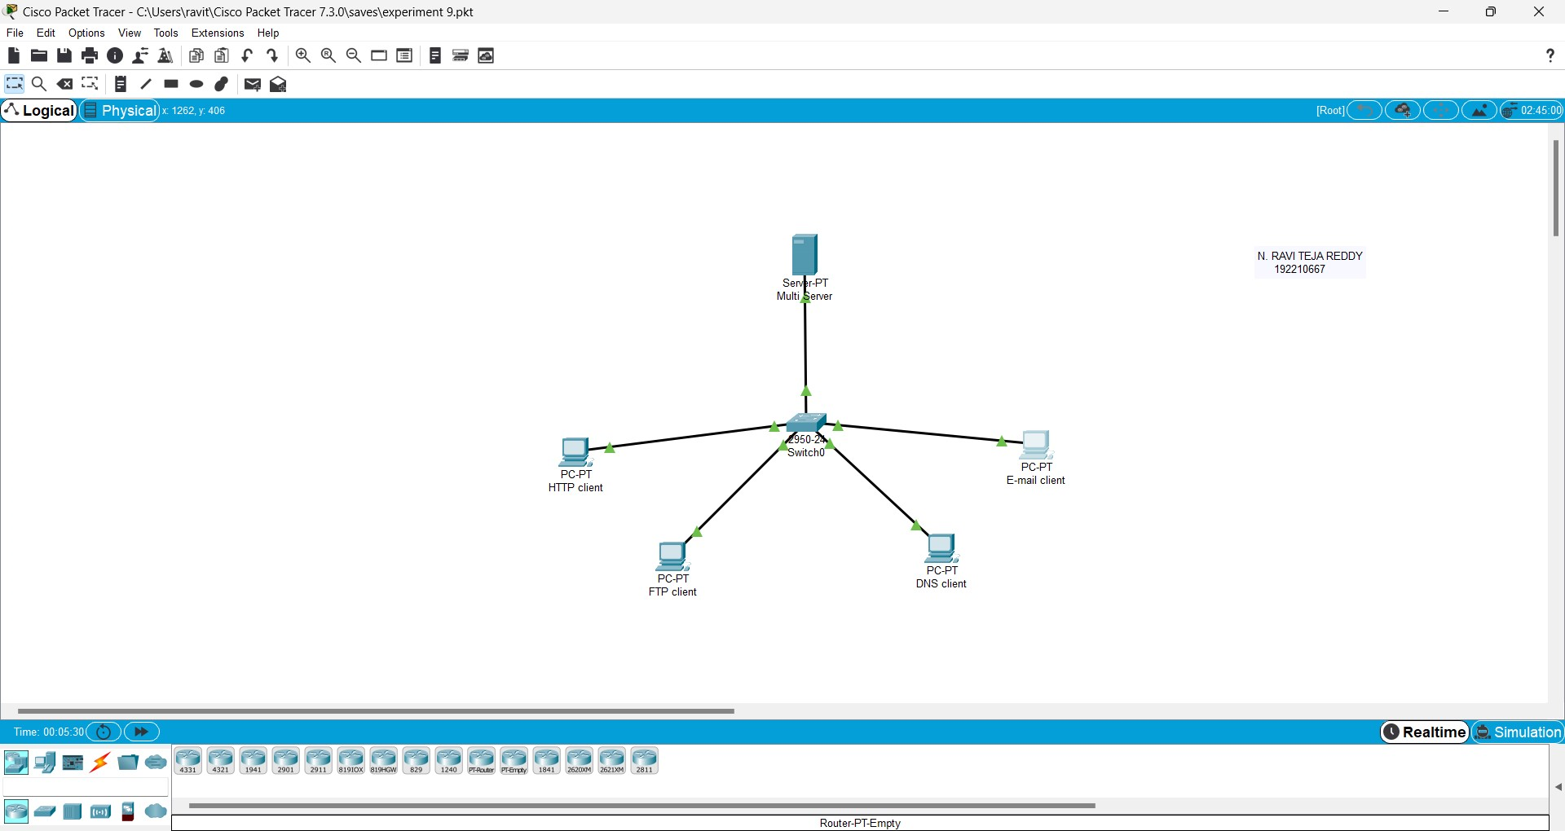

Experiment 11 IOT baeed smart home

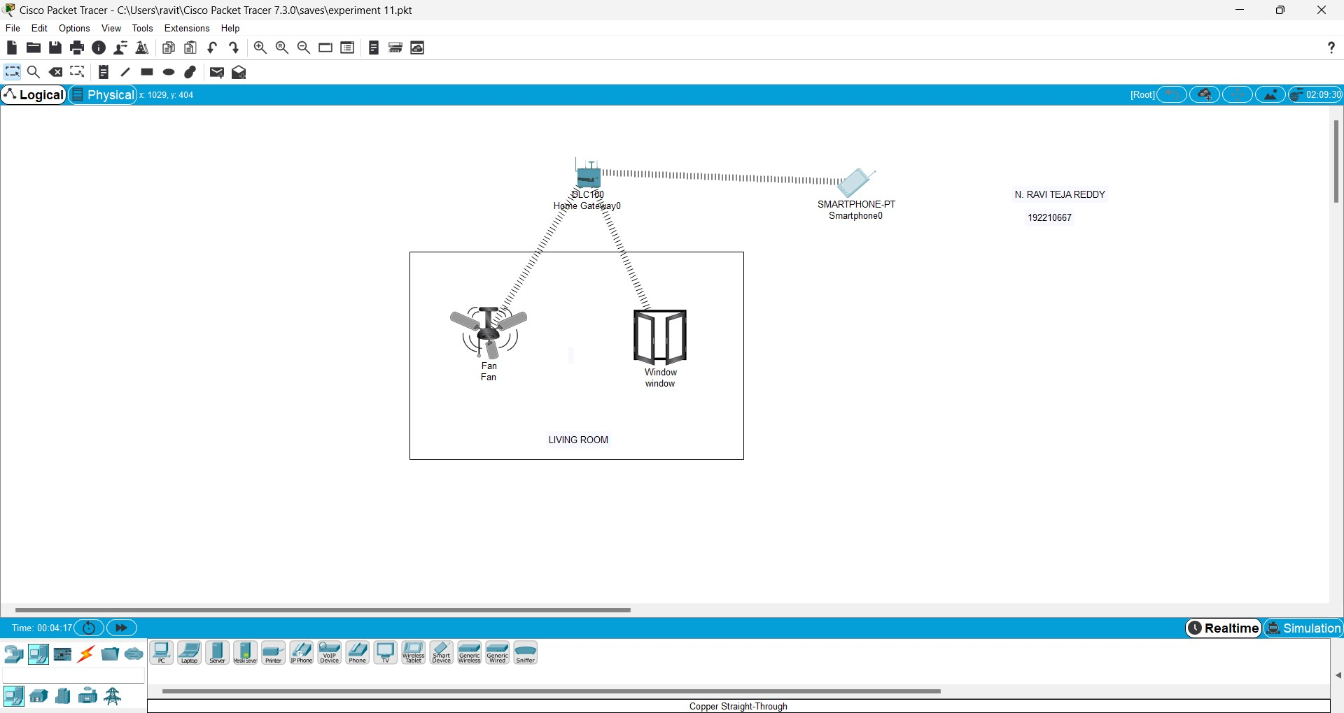

Experiment 12 smart garden in cisco packet tracer

